 | 12.1.13 Editors - Geometry Nodes Editor - Header - Add Menu - Geometry - Sample
Table of content
Detailed table of content 1
Add menu - Geometry - Sample 2
Geometry Proximity 2
Index of Nearest 3
Raycast 4
Sample Index 5
Sample Nearest 6

Detailed table of content
Detailed table of content
Detailed table of content 1
Add menu - Geometry - Sample 2
Geometry Proximity 2
Inputs 2
Geometry 2
Group ID 2
Sample Position 3
Sample Group ID 3
Properties 3
Target Geometry 3
Outputs 3
Position 3
Distance 3
Is Valid 3
Index of Nearest 3
Inputs 3
Position 3
Group ID 3
Outputs 3
Index 3
Has Neighbor 4
Raycast 4
Inputs 4
Target Geometry 4
Attribute 4
Interpolation 4
Source Position 4
Ray Direction 4
Ray Length 4
Properties 4
Data Type 4
Output 4
Is Hit 4
Hit Position 5
Hit Normal 5
Hit Distance 5
Attribute 5
Sample Index 5
Inputs 5
Geometry 5
Value 5
Index 5
Properties 5
Data Type 5
Domain 5
Clamp 6
Output 6
Value 6
Sample Nearest 6
Inputs 6
Geometry 6
Sample Position 6
Properties 6
Domain 6
Output 6
Index 6

Add menu - Geometry - Sample
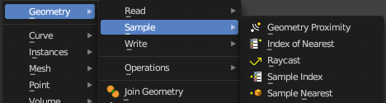
Here you find nodes to modify the geometry.

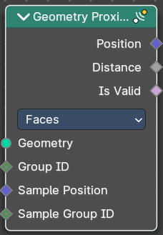
Geometry Proximity
This node finds the closest position on the target for each point in the input geometry.

Inputs

Geometry
The target object.

Group ID
Is evaluated on the face domain, and splits the input mesh into multiple parts, each with its own id.

Sample Position
The position where the computed location is stored.

Sample Group ID
Determines in which group the closest nearest surface is detected.

Properties

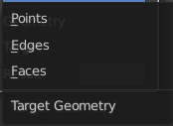
Target Geometry
The element of the target geometry to calculate the distance from.

Outputs

Position
Closest location on the surface of the target mesh, or the closest point in the target point cloud in Points mode.

Distance
Distance from the source position to the closest location in the target.

Is Valid
Wether the sampling was successful. It is false when the sampled group is empty.

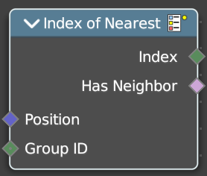
Index of Nearest
Retreive values from specific geometry elements.

Inputs

Position
The position of the nearest element.

Group ID
The group ID of the nearest element.

Outputs

Index
The Index of the nearest element.

Has Neighbor
Has this element a neighbor.

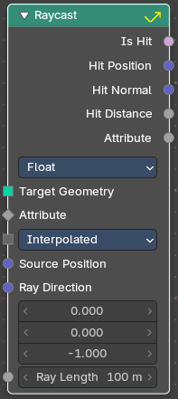
Raycast
This node sends a raycast and retreives data from the hit target.

Inputs

Target Geometry
This is actually the source object that sends the ray.

Attribute
Attribute input.

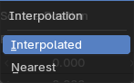
Interpolation
Mapping from the target geometry to hit points.

Source Position
Source position input.

Ray Direction
A vector 3 for the ray direction.

Ray Length
The length of the ray.

Properties

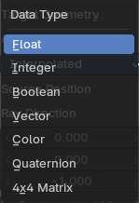
Data Type
What data to calculate on hit.

Output

Is Hit
Has the raycast hit something?

Hit Position
The hit position if any.

Hit Normal
The normal of the hit point.

Hit Distance
The distance of the hit point.

Attribute
The attribute of the hit object.

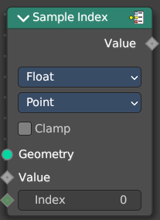
Sample Index
Retreive values from specific geometry elements.

Inputs

Geometry
The source object to take the data from.

Value
The value to retreive.

Index
The index position of the value.

Properties

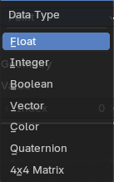
Data Type
The type for the source and result data.

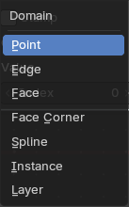
Domain
What kind of data to process.

Clamp
Clamp the indices to the size of the attribute domain.

Output

Value
The output value.

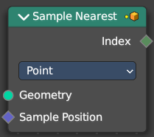
Sample Nearest
Retreives the element of a geometry closest to a position.

Inputs

Geometry
The source object to take the data from.

Sample Position
The position of the source object.

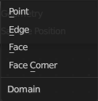
Properties

Domain
What data to process.

Output

Index
The index output.

